**“COSY AIR-CONDITIONERS”**

**“Orient”**

**“Models”**

**“Orient DC Inverter Easy Clean 1 Ton Split”**

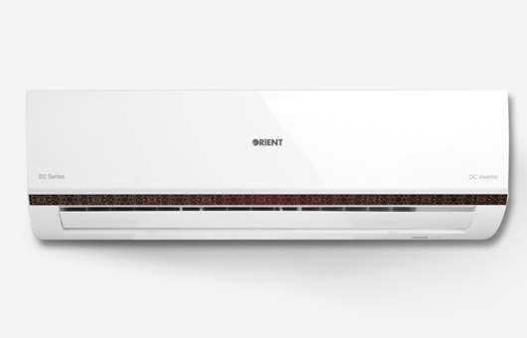

**Key Features**

* Easy Clean Function
* Louver Position Memory
* 4 Way Cooling
* Low Voltage Operation up to 150v
* Heat and Cool Function

**Specification**

* **Cooling - Rated Capacity**
* 3500 (1500-3900) W
* **Cooling - Rated Power Consumption**
* 1100 (420-1560) W
* **Cooling - Running Current**
* 4.8 (2.0-6.8) A
* **SEER - Cooling**
* 3.6
* **Heating - Rated Capacity**
* 3500 (1600-4000) W
* **Heating - Rated Power Consumption**
* 1050 (430-1600) W
* **Heating - Running Current**
* 4.6 (1.9-7.0) A
* **SEER - Heating**
* 3.6
* **Low Voltage Operation**
* Yes

**RS ~ 54,000.**

**“Orient DC Inverter Inventage”**

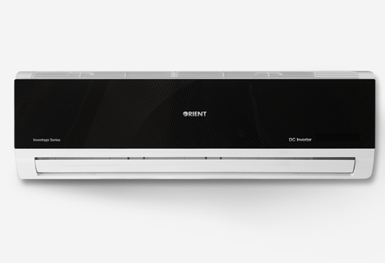

**Key Features**

* Easy Clean Function
* Louver Position Memory
* 4 Way Cooling
* Low Voltage Operation up to 150v
* Heat and Cool Function

**Specifications**

* **Cooling - Rated Capacity**
* 5200 (2200-5700) W
* **Cooling - Rated Power Consumption**
* 1640 (550-2200) W
* **Cooling - Running Current**
* 7.2 (2.5-9.7) A
* **SEER - Cooling**
* 3.6
* **Heating - Rated Capacity**
* 5200 (2400-6000) W
* **Heating - Rated Power Consumption**
* 1600 (600-2300) W
* **Heating - Running Current**
* 7.1 (2.6-10.2) A
* **SEER - Heating**
* 3.6
* **Low Voltage Operation**
* Yes

**RS ~ 60,000.**

**“Orient DC Inverter Prime”**

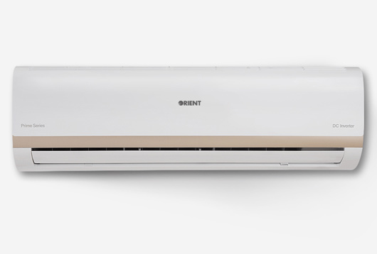

**Key Features**

* Sleek Design, Oval Shape
* 4 Way Cooling
* High Density Filter
* Low Voltage Operation up to 150v
* Heat and Cool Function
* **Specifications**
* **Cooling - Rated Capacity**
* 5200 (2200-5700) W
* **Cooling - Rated Power Consumption**
* 1640 (550-2200) W
* **Cooling - Running Current**
* 7.2 (2.5-9.7) A
* **SEER - Cooling**
* 3.6
* **Heating - Rated Capacity**
* 5200 (2400-6000) W
* **Heating - Rated Power Consumption**
* 1600 (600-2300) W
* **Heating - Running Current**
* 7.1 (2.6-10.2) A
* **SEER - Heating**
* 3.6
* **Low Voltage Operation**
* Yes

**RS ~ 58,000.**

**“Orient DC Inverter Ultron Plus”**

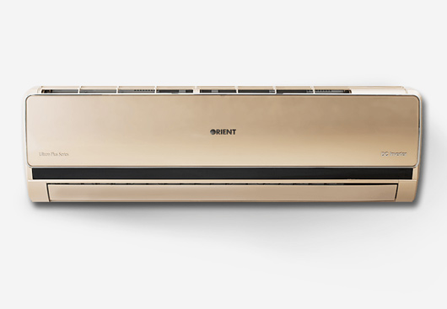

* Biggest Indoor and Outdoor Units
* 4 Way Cooling
* Super Quiet Design
* Heat and Cool Function
* Low Voltage Operation
* **Specifications**
* **Cooling - Rated Capacity**
* 6400 (2800-7000) W
* **Cooling - Rated Power Consumption**
* 2020 (730-2600) W
* **Cooling - Running Current**
* 8.8 (3.4-11.4) A
* **SEER - Cooling**
* 3.6
* **Heating - Rated Capacity**
* 6400 (2900-7200) W
* **Heating - Rated Power Consumption**
* 2020 (800-2700) W
* **Heating - Running Current**
* 8.8 (3.6-11.8) A
* **Low Voltage Operation**
* Yes
* **Title 15**
* very good
* **RS ~ 96,000.**

**“Orient DC Inverter Ultron”**

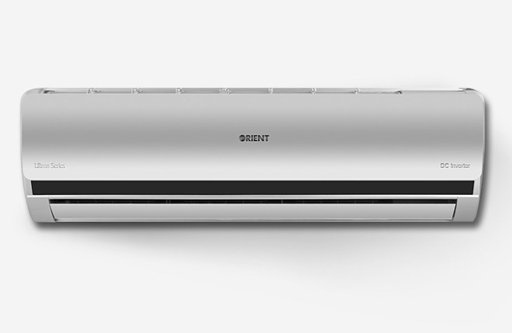

**Key Features**

* Low Voltage Operation up to 140v
* Heat and Cool Function
* Biggest Indoor and Outdoor Units
* 4 Way Cooling
* Easy Installation
* **Specifications**
* **Cooling - Rated Capacity**
* 6400 (2800-7000) W
* **Cooling - Rated Power Consumption**
* 2020 (730-2600) W
* **Cooling - Running Current**
* 8.8 (3.4-11.4) A
* **SEER - Cooling**
* 3.6
* **Heating - Rated Capacity**
* 6400 (2900-7200) W
* **Heating - Rated Power Consumption**
* 2020 (800-2700) W
* **Heating - Running Current**
* 8.8 (3.6-11.8) A
* **Low Voltage Operation**
* Yes
* **RS ~ 94,000.**